SPECIAL REPORT

The San Bernardino Shooting 2/12/2015

What do we know?
Dr. Michael Barak
Devorah Margolin

Overview of the Attack
On December 2, 2015, Syed Rizwan Farook and his wife Tashfeen Malik entered the Inland Regional Center in San Bernardino California (the work place of Farook), and opened fire on a holiday party. The terrorist attack killed 14 people and injured 21 more, making it was the deadliest terrorist attack on US soil since 9/11 (killed 2,977 people).

The Weapons
Syed Rizwan Farook and Tashfeen Malik carried four guns (two rifles and two semi-automatic handguns), 12 pipe bombs and 4,500 rounds of ammunition. The weapons were all purchased legally in California between 2007 and 2012. The couple bought the handguns, while a third suspect, Enrique Marquez Jr., bought the two rifles in 2011 and 2012.

Timeline of the Attack:
10:00 - Sayed Rizwan Farook attends a workplace holiday party. Reports state he fought with a co-worker and left the party. Between 10-30 minutes later he returned with his wife, Tashfeen Malik.
11:00 - Calls to 911 reported shots fired at the Inland Regional Center in San Bernardino California at an office holiday party. The suspects, dressed in combat gear, entered the building from the east side, and fired over 75 rounds. A fire alarm was triggered. On a daily basis, approximately 550 people work at the complex. The shooting lasted only minutes, before the suspects (Rizwan Farook and Tashfeen Malik) left the scene in a black SUV.
11:05 - Within minutes, police arrived and evacuated victims. Undetonated explosives were found at the scene.
11:40 - Police close down roads in the area, looking for the shooters.
15:20 - A shootout ensured between police and individuals in a black SUV in a residential neighborhood. Both attackers were killed.
17:00 - Police search the suspects' house in Redlands and find weapons, ammunition and pipe bombs. The hard drive of their computer was missing and two new cell phones were found destroyed and found in the trash.
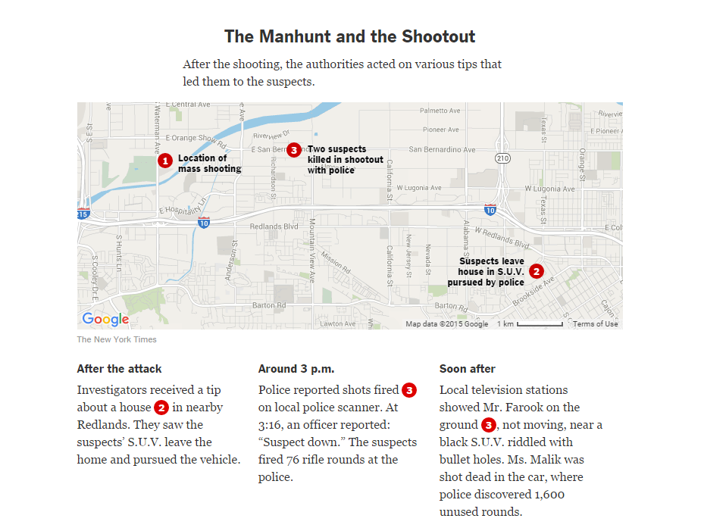

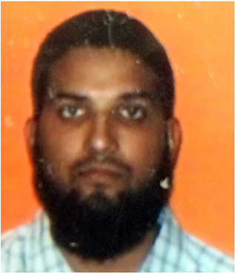
Suspects:
Syed Rizwan Farook, 28, an American-born citizen of Pakistani origin. He was born June 14, 1997 in Illinois and raised in California. He had two siblings (a sister and a navy decorated brother), and his parents were divorced. His mother was living with him at the time of the attack.
Rizwan Farook traveled twice to Saudi Arabia and once to Pakistan. He met his wife, Tashfeen Malik, via an online dating service and both were radicalized by the time they met. She came to the USA in 2014 on a fiancée visa. They had one child together, Maryam Bint Rizwan on May 21, 2015.
Between 2012 and 2014, Farook was a regular at the Riverside Mosque. At the time of the shooting, he prayed at the Dar Al Uloom Al Islamiyah-Amer Mosque in San Bernardino California.
Farook graduated from California State University, San Bernardino. He also studied for (but did not complete) a graduate degree at California State University, Fullerton. From July to December 2010, Farook worked as a seasonal public employee. In January 2012 he was hired as an environmental health inspector, and in 2014, he was promoted.
Farook often went to a shooting range in Riverside with his wife. The week before his attack, on November 29 and 30, he went to the Riverside Magnum Shooting Range to shoot an assault rifle and a handgun. His wife also joined him.
It is believed that Farook and Marquez may have been plotting to attack a school in California in 2011 or 2012 (when the guns were first purchased).
Tashfeen Malik, 29, was married to Syed Rizwan Farook. Born in Pakistan, she moved to Saudi Arabia with her father at a young age. She had two brothers and two sisters. She returned to Pakistan in 2007 to go to pharmacology school at Bahauddin Zakariya University. She lived in the University dorms until 2012. Family and friends claimed she became religious and radicalized during college. The couple met via an online dating service and were both radicalized by the time they met.
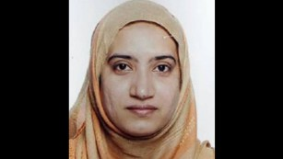
Malik came to the USA in 2014 on a fiancée visa and was granted a green card in 2015. Questions arise as she was not only a woman, but a new mother. Their daughter, Maryam Bint Rizwan, was born on May 21, 2015. Friends and family claimed that she would not speak to male relatives and wore a niqab.
Enrique Marquez Jr., 24, a friend and neighbor of Farook's from Riverside. In 2011 and 2012, Marquez bought the two semi-automatic rifles used in the attacks. He converted to Islam approximately four years ago. He checked himself into a mental hospital after the shooting.
Reports emerged that Marquez was married to Farook's sister-in-law, Mariya Chernykh in November 2014. However, it appears to have been a sham marriage to allow her to enter the country. Russian born Chernykh arrived in 2009 to visit her sister Tatiana (married to Rizwan Farook's brother Rahel Farook).
It is believed that Farook and Marquez may have been plotting to attack a school in California in 2011 or 2012 (when the guns were first purchased).
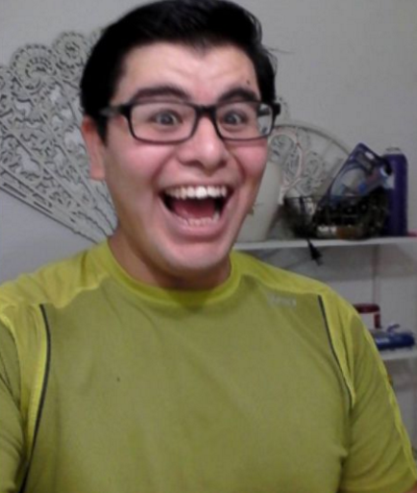

Timeline of the Suspects:
2011-2012 - The four guns were purchased.
October 2013 - Syed Rizwan Farook traveled to Saudi Arabia for Hajj.
July 2014 - Syed Rizwan Farook traveled to Saudi Arabia and returned with Tashfeen Malik, who used a Pakistani passport and entered on a K-1 Visa (fiancée Visa).
September 30, 2014 - Tashfeen Malik applied for a green card.
May 21, 2015 - Syed Rizwan Farook and Tashfeen Malik have a daughter, Maryam Bint Rizwan, in Riverside California.
July 2015 - Tashfeen Malik is granted a conditional green card. In order to get this, she passed criminal and national security background checks.
Family claims that they did not know they attackers were radicalized. However, an interview with Rizwan Farook's father, Syed Rahil Farook, shows a deep hatred for Israel and that he was fascinated by ISIS.

Money:
- Two weeks before the attack, $28,000 was transferred into their bank account.
- Farook took out $10,000 in cash on November 20.
- Three transfers of $5,000 were sent to Farook's mother.

Connections:
While Tashfeen Malik is believed to have connections to ISIS, her husband, Farook, had come into contact with both Al Nusra Front and Al Shabaab.

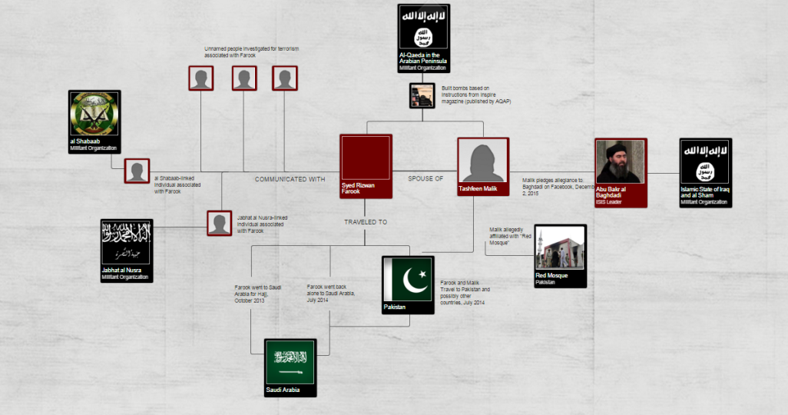

Responsibility:
During the attack, at approximately 11:00 AM, Tashfeen Malik pledged allegiance to the Islamic State in a Facebook post.
ISIS, via a radio station broadcast, claimed the attackers were supporters of ISIS and praised them for the attack.
It is important to note the word choice; ISIS claimed they were supporters of the organization, but not members.

Governmental Response:
President Obama delivered an address on Sunday December 6, 2015, four days after the attack. The address was only the third of its kind that Obama has delivered in his time in office. Obama condemned the attacks as terrorist attacks and stated they were the result of a "twisted version of Islam".
The FBI described the attack as a terrorist attack inspired by Sunni Muslim extremist groups.

Social Media Discourse on the San Bernardino Attacks
The jihadi discourse on the terrorist attack in San Bernardino in California is quite minimal. This is probably because the attack was not conducted by ISIS itself. However ISIS inspired the two attackers as it announced via its Al-Bayan broadcasting in Iraq that two of ISIS’s supporters launched an attack in San Bernardino:
“30 Americans were killed and wounded in an attack that was carried out by two supporters of the Islamic State before few days ago in California.. The two supporters of IS attacked a center in San Bernardino in California and shot inside the center. This caused to the death of 14 people and to wound more than 20 people. After that, there were shootings with the American police which expelled the, for several hours – what brought them to death”.
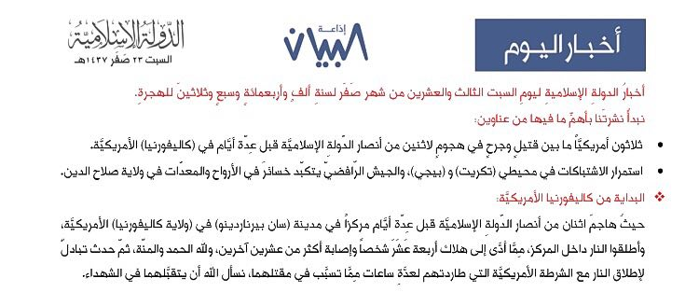
Transcript of the message that was broadcasted on Al-Bayan concerning the attack in San Bernardino.

On Social Media Networks few ISIS’s supporters have praised the attack. One twitter user, for example, threatened to set fire to all of California, while another one threatened to carry out more attacks in the US, this time against the White House. Other twitter users said that the big problem of the West was to cope with the ideology of the Islamic State, which inspires many to carry out attacks such as in California. Another ISIS supporter called to invest efforts in promoting this attack on the media.
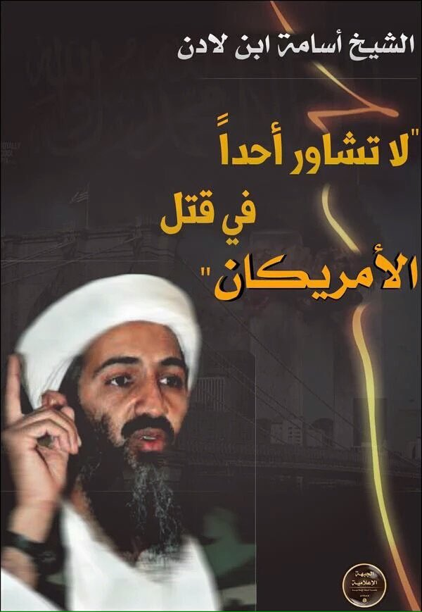
A banner that one of ISIS’s supporter uploaded to twitter. It is saying: “Sheikh Osama bin Laden: Don’t consult no one in killing Americans”

Appendices

Appendix 1:
Deadliest terror attacks in the USA since 9/11
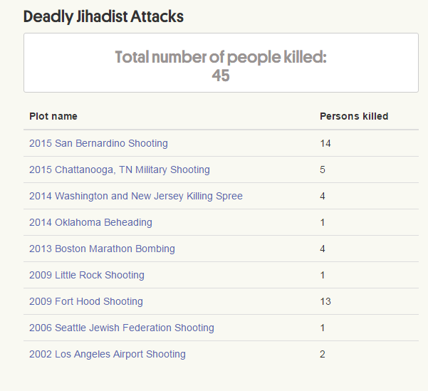

Appendix 2:
According to "Terrorism Since 9/11: The American Cases" Edited by John Mueller, as of early 2015 there were 61 well known terrorist attacks and plots on the US.
(Taken as a direct quote from the book)
- The shoe bomber - 2001 British man tries to blow up a US-bound airliner with explosives in his shoes but is subdued by passengers and crew
- Padilla - 2002 American connected to al-Qaeda who had discussed a dirty bomb attack returns to US and is arrested
- Mt. Rushmore - 2002 Two men in Florida, one of them possibly connected to an al-Qaeda operative, plot, crucially aided by an informant, to bomb local targets as well as Mt. Rushmore before 9/11, and are arrested and tried the year after
- El Al at LAX - 2002 A depressed anti-Israel Egyptian national shoots and kills two at the El Al ticket counter at Los Angeles airport in an act later considered to be one of terrorism, and then is killed by a guard
- Lackawanna - 2002 Seven Americans in Lackawanna, NY, are induced to travel to an al-Qaeda training camp, but six return disillusioned, all before 9/11, and are arrested the next year
- Khan and the Parachas - 2003 A young Pakistani seeks to help an al-Qaeda operative enter the country to attack underground storage tanks and gas stations
- Abu Ali in Saudi Arabia - 2003 A US citizen joins a terrorist cell in Saudi Arabia and plots to hijack a plane in the US and to assassinate President Bush when he is arrested by the Saudis and extradited to the US for trial
- Columbus and the Brooklyn Bridge - 2003 American connected to al-Qaeda discusses shooting up a shopping mall in Columbus, OH, with two friends, then scouts taking down the Brooklyn Bridge for al-Qaeda, but decides it's too difficult
- Barot and the financial buildings - 2004 Group in London tied to al-Qaeda scouts out financial buildings in US with an eye to bombing them, but never gets to the issue of explosives
- Albany - 2004 Two men in Albany, NY, effectively help fund an informant's terror plot
- Nettles - 2004 An American with a long history of criminal and mental problems plots under the nickname of "Ben Laden" to blow up a federal courthouse in Chicago and reaches out for help to a Middle Eastern terrorist group, but gets the FBI
- Herald Square - 2004 Loud-mouthed jihadist in New York and a schizophrenic friend attract informant who helps them lay plans to bomb Herald Square subway station
- Grecula - 2005 An American with visions of being an modern day Spartacus agrees to build a bomb to be exploded in the US for undercover agents claiming to be al-Qaeda
- Lodi - 2005 American in Lodi, California, who may have attended a training camp in Pakistan but with no apparent plan to commit violence is arrested with the aid of an informant
- JIS - 2005 American in jail masterminds a plot by three others to shoot up military recruitment centers, synagogues, and a non-existent military base in the Los Angeles area but, although close to their first attack, the plot is disrupted when they leave a cell phone behind at a funds-raising robbery
- Pipelines and the terrorist hunter - 2005 An American offers on the internet to blow up pipelines in Canada as an aid to al-Qaeda, and attracts the attention of free-lance informant
- U of North Carolina - 2006 To punish the US government for actions around the world, a former student, after failing to go abroad to fight or to join the Air Force so he could drop a nuclear bomb on Washington, drives a rented SUV onto campus to run over as many Americans as possible and manages to injure nine
- Hudson River tunnels - 2006 Angered by the US invasion of Iraq, several men plot on the internet to flood railway tunnels under the Hudson river, but are arrested overseas before acquiring bomb materials, meeting each other in person, or setting foot in the US
- Sears Tower - 2006 Seven men in Miami plot with an informant, whom they claim they were trying to con, to take down the Sears Tower in Chicago, then focus on closer buildings
- Bombings transatlantic airliners - 2006 Small group in London, under intense police surveillance from the beginning, plots to explode liquid bombs on US-bound airliners
- Rockford Mall - 2006 Loud mouthed jihadist attracts attention of an informant and together they plot exploding grenades at a shopping mall in Rockford, IL
- Fort Dix - 2007 Small group target practices, buys guns, and plots to attack Ft. Dix, NJ, with the aid of an informant who joins the group when the FBI is told they took a jihadist video into a shop to be duplicated
- JFK airport - 2007 Small group, with informant, plots to blow up fuel lines serving JFK airport in New York
- Vinas - 2008 New York man travels to Pakistan, is accepted into al-Qaeda, and plots to plant a bomb in the US, but is being watched and talks after being arrested
- Bronx synagogues - 2009 Four men, with crucial aid from an informant, plot to bomb synagogues in Bronx, NY, and shoot down a plane at a military base
- Little Rock - 2009 American man travels to Middle East to get training, but fails, and on return, working as a lone wolf, eventually shoots and kills one soldier at a military recruitment center in Little Rock, AK
- Boyd and Quantico - 2009 Complicated conspiracy in North Carolina including an informant, gathers weapons and may have targeted Quantico Marine Base
- Zazi - 2009 Afghan-American and two friends travel to Pakistan to join Taliban, but are recruited by al-Qaeda to plant bombs on NY subways instead, and are under surveillance throughout
- Springfield - 2009 Loud mouthed jihadist plots, with informants, to set off a bomb in Springfield, IL
- Dallas skyscraper - 2009 Jordanian on a student visa rouses interest from the FBI in internet postings and, together with three agents, tries to detonate a fake bomb in the basement of a Dallas skyscraper
- Mehanna - 2009 Well-educated Muslim jihadist may have plotted briefly to shoot up a shopping center in the Boston area and tried to join insurgency in the Middle East, but is arrested for spreading jihadist propaganda
- Killings at Fort Hood - 2009 Military psychiatrist, acting as a lone wolf, shoots up a military deployment center in Ft. Hood, TX, killing 12 soldiers and one civilian, shortly before he is supposed to be deployed to the war in Afghanistan
- The underwear bomber - 2009 Nigerian man tries to blow up a US-bound airliner with explosives in his underwear but is subdued by passengers and crew
- Times Square - 2010 Pakistani-American gets training in Pakistan and on his own tries, but fails, to set off a car bomb at Times Square in New York
- Alaska - 2010 Muslim convert in a remote Alaska town plots the assassination of 20 with the aid of an informant
- Parcel bombs on cargo planes - 2010 An effort by al-Qaeda in the Arabian Peninsula to set off parcel bombs implanted in printer cartridges on cargo planes bound for the United States is disrupted by an insider
- DC Metro—bomb plot - 2010 A Pakistani-American aids FBI operatives posing as al-Qaeda in a plot to bomb the DC Metro
- Oregon - 2010 Teenaged Somali-American jihadist, unable to go abroad to fight, works with FBI operatives, apparently alerted by his father, to set off a van bomb at a Christmas tree lighting ceremony in Portland, OR
- DC Metro—Facebook - 2010 Virginia man brags without substance to a female Facebook correspondent that he will bomb the Washington Metro soon, and is quickly arrested for making interstate threats, receiving a light sentence
- Baltimore - 2010 Baltimore man seeks allies on Facebook for violent jihad, and the FBI supplies him with an informant and with a fake SUV bomb with which he tries to blow up a military recruitment center
- Texas - 2011 Saudi student in Texas, flunking out and displaying intense new discontent on his blog and Facebook profile, is arrested after buying bomb-making materials and considering potential targets including crowded streets in distant New York and a local residence of former President George W. Bush
- Manhattan's pair of lone wolves - 2011 Upset with how the US treats Muslims around the world mentally ill American citizen, with accomplice and undercover officer, purchases weapons as the first step in a plot to blow up synagogues, the Empire State Building, and other targets in New York and New Jersey
- Pentagon shooter - 2011 A US marine reservist with jihadist literature shoots at military buildings in the DC area and is arrested as he seeks to desecrate the graves of veterans of the wars in Iraq and Afghanistan
- Seattle - 2011 Two financially-destitute men, exercised over US foreign policy, are arrested in Seattle after they purchase an FBI-supplied machine gun that they plan to use to attack a military recruiting center after they save up enough money to purchase bullets and other material
- Abdo - 2011 A US Army Private, unwilling to wage war on Muslims, is arrested after he buys ammunition and bomb materials to explode in a restaurant popular with soldiers
- Model planes - 2011 Seeking to “decapitate” the US “military center,” a mentally-ill hobbyist plots with police operatives to attack the Pentagon with remote-controlled model planes bearing explosives and then to shoot at people as they flee the building
- Iran and Scarface - 2011 An Iranian-American used-car salesman from Texas, nicknamed “Scarface” from the results of an earlier street brawl, is engaged for a promised $1.5 million by members of the Iranian government to arrange for a Mexican drug cartel to blow up Saudi Arabia's ambassador in a Washington restaurant but is foiled by an undercover Drug Enforcement Agency operative who is wired $100,000 as a down payment
- Pimentel’s pipe bomb - 2011 A naturalized US citizen and Muslim convert, hostile to US military ventures in the Middle East, seeks to make pipe bombs using match heads to attack various targets
- Tampa - 2012 Under suspicion after he walked into a store seeking to purchase an al-Qaeda flag, an Albanian-American loner plots in Tampa with a police operative to detonate a car bomb, fire an assault rifle, wear an explosive belt, take hostages, and bomb nightclubs, a police center, several bridges, and a Starbuck's coffee shop in order to avenge wrongs against Muslims and to bring terror to his “victims' hearts”
- Capitol bomber - 2012 A Moroccan man who had overstayed his visa for years and had been thrown out of his apartment for non-payment of rent, concludes that the war on terror is a war on Muslims, plots with FBI operatives, and is arrested as he seeks to carry out a suicide bombing at the Capitol
- Chicago bar - 2012 Drawn by the violent jihadist emails and internet postings composed by an unemployed and apparently retarded 18-year-old Egyptian-American who felt the US was at war with Islam, FBI agents gain his confidence, supply him with a fake bomb which he parks outside a Chicago bar he said was filled with “the evilest people,” and then arrest him when he attempts to detonate it from a nearby alley
- Bombing the Federal Reserve Bank - 2012 A college flunk-out from Bangladesh uses his parents’ life-savings to study in the US and reaches out on Facebook, obtains the help of the FBI to do something that will “shake the whole country,” and is arrested when he tries to set off an FBI-supplied bomb planted at the Federal Reserve Bank from a nearby hotel room
- The brothers - 2012 Two brothers in Florida plot to set off a bomb in New York in revenge for US drone attacks in Afghanistan, but are arrested before getting very far beyond bicycling around Manhattan looking for targets
- Boston marathon - 2013 Two Chechen-American brothers, working alone, detonate two homemade bombs in a crowd at the Boston marathon, killing three, and then are killed or captured in a several-day manhunt
- Wichita airport - 2013 A worker at the Wichita, Kansas, airport plots with FBI agents to detonate a car bomb at dawn at the airport
- Rochester - 2014 A local man, in sympathy with Islamic State militants, plots with FBI operatives to shoot and kill members of the U.S. military
- Cincinnati - 2015 A young local loner, in sympathy with ISIS, plots with FBI operatives to set off a bomb at the Capitol in Washington, DC
- Aurora - 2015 Unable to travel abroad to fight because of a felony conviction for trying to rob a McDonalds, an Illinois man plots with FBI operatives to “unleash the lion” by attacking a local National Guard Armory
- Two women in Queens - 2015 Protesting that “It’s war” and “Protest don’t work” and “Why can’t we be some real bad bitches?” two women, one in communication with al-Qaeda in Yemen, try to fabricate bombs with the aid of an undercover officer
- Fort Riley - 2015 A young man enthusing on Facebook about being killed in jihad, plots with FBI operatives to explode a 1000-pound bomb at a nearby military base
- Ohio returnee from Syria - 2015 A Somali-American, actively communicating about his plans on social media, travels to the Middle East, stays about a month, receives some training, returns, and may have planned to commit violence

http://www.nytimes.com/interactive/2015/12/02/us/california-mass-shooting-san-bernardino.html
http://www.peopleplotr.com/plot/entry/15225/San-Bernardino-Shooting/?utm_source=San+Bernardino+Shooting+a+Terrorist+Attack+with+al-Qaeda+and+ISIS+Footprints&utm_campaign=Russian+Airstrikes+in+Syria%3A+November+11+-+November+29%2C+2015&utm_medium=email
5.12.15. https://twitter.com/boshgma/status/673069008204210176
4.12.15. https://twitter.com/_iraq13_/status/673016275229126656
4.12.15. https://twitter.com/Thabat_media/status/672868445038448641
4.12.15. https://twitter.com/Dc33tt/status/672889882247852032
4.12.15. https://twitter.com/Thabat_media/status/672858629029130240
6.12.15. https://twitter.com/advbwr2/status/673648085428543488
http://securitydata.newamerica.net/extremists/deadly-attacks.html
http://politicalscience.osu.edu/faculty/jmueller/since.html

